**MADLAB Project with Firebase:**

**Firebase:**

Introduction

In the era of rapid prototyping, we can get bright ideas, but sometimes they are not applicable if they take too much work. Often, the back-end is the limiting factor - many considerations never apply to server-side coding due to lack of knowledge or time.

Firebase is a Backend-as-a-Service(BaaS) which started as a YC11 startup. It grew up into a next-generation app-development platform on Google Cloud Platform. Firebase (a NoSQLjSON database) is a real-time database that allows storing a list of objects in the form of a tree. We can synchronize data between different devices.

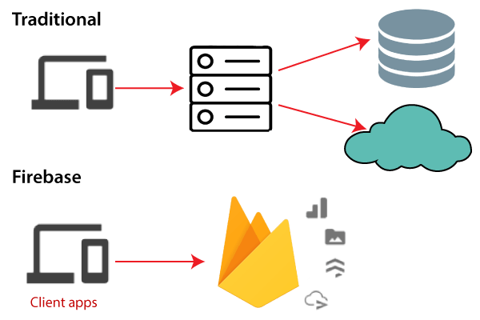

Google Firebase is Google-backed application development software which allows developers to develop **Android, IOS,** and **Web apps**. For reporting and fixing app crashes, tracking analytics, creating marketing and product experiments, firebase provides several tools. Firebase has three main services, i.e., a real-time database, user authentication, and hosting.

## **History of Firebase**

**Firebase** evolved from **Envolve**. Envolve is a prior startup founded by **James Tamplin** and **Andrew Lee** in 2011. Envolve provided developers an API which allowed the integration of online chat functionality into their websites. After releasing the chat service, it found that the envlove was being used to pass application data, which were not chat messages. Developers used Envolve to sync application to separate the real-time architecture and the chat system which powered it. In September 2011, Tamplin and Lee founded firebase as a separate company. It was lastly launched to the public in April 2012.

Firebase Real-time Database was the first product of firebase. It is an API which syncs application data across Android, iOS, and Web devices. It gets stored on Firebase's cloud. Then the firebase real-time database helps the developers to build real-time, collaborative applications.

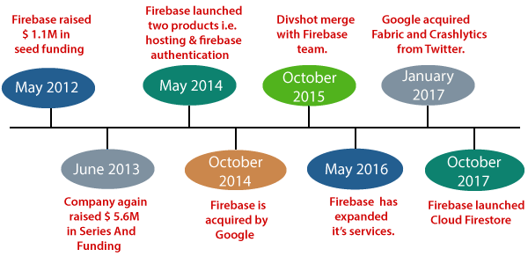

## **Why use Firebase?**

* Firebase manages real-time data in the database. So, it easily and quickly exchanges the data to and from the database. Hence, for developing mobile apps such as live streaming, chat messaging, etc., we can use Firebase.
* Firebase allows syncing real-time data across all devices - iOS, Android, and Web - without refreshing the screen.
* Firebase provides integration to Google Advertising, AdMob, Data Studio, BigQuery DoubleClick, Play Store, and Slack to develop our apps with efficient and accurate management and maintenance.
* Everything from databases, analytics to crash reports are included in Firebase. So, the app development team can stay focused on improving the user experience.
* Firebase applications can be deployed over a secured connection to the firebase server.
* Firebase offers a simple control dashboard.
* It offers a number of useful services to choose from.

## **Pros and Cons of Firebase**

Firebase has a lot of pros or advantages. Apart from the advantages, it has disadvantages too. Let's take a look at these advantages and disadvantages:

### **Pros**

* Firebase is a real-time database.
* It has massive storage size potential.
* Firebase is serverless.
* It is highly secure.
* It is the most advanced hosted BaaS solution.
* It has minimal setup.
* It provides simple serialization of app state.
* We can easily access data, files, auth, and more.
* There is no server infrastructure required to power apps with data.
* It has JSON storage, which means no barrier between data and objects.

### **Cons**

* Firebase is not widely used, or battle-tested for enterprises.
* It has very limited querying and indexing.
* It provides no aggregation.
* It has no map-reduce functionality.
* It cannot query or list users or stored files.

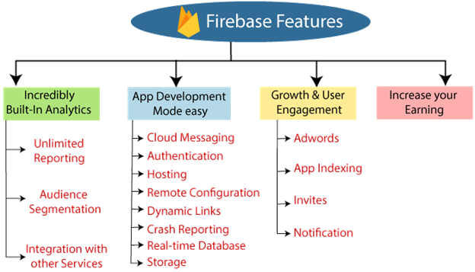

# Firestore



We have two options with Firebase, i.e., Firebase Real-time Database and Cloud Firestore. Cloud Firestore is newer, but it is not replacing the Firebase Real-time Database. Cloud Firestore is a flexible as well as scalable NoSQL cloud database. It is used to store and sync data for client and server-side development. It is used for mobile, web, and server development from Google Cloud Platform and Firebase. Like the Firebase Real-time Database, it keeps syncing our data via real-time listeners to the client app. It provides offline support for mobile and web so we can create responsive apps that work regardless of network latency or Internet connectivity.

Cloud Firestore also provides seamless integration with Google Cloud Platform products and other Firebase, including cloud functions.

## **Key capabilities**

**Flexibility**

The Firestore data model supports a flexible, hierarchical data structure. It stores our data in the document, which is organized into a collection. In Firestore, the documents can contain complex nested objects rather than sub-collections.

**Expressive querying**

In Firestore, we can use queries for retrieving specific, individual documents or for retrieving all the documents in a collection that match our query parameters. Our queries combine filtering and sorting and can include multiple, chained filters. The query performance is proportional to the size of our result set because queries are indexed by default.

**Real-time updates**

Firestore is quite similar to Firebase Realtime Database. Firestore also uses data synchronization for updating data on any connected device. It is designed for making simple one time fetch queries efficiently.

**Offline Supports**

Cloud Firestore enables us to make a cache of the app data, which it is actively using. This makes the app to read, write, query, and listen to the data even when the device is offline. When the device comes in an online mode, Cloud Firestore synchronizes the local changes back to it.

**Designed to scale**

Cloud Firestore provides us the best infrastructure of the Google Cloud Platform: automated multi-region data replication, atomic batch operations, strong consistency guarantees, and real transaction support. We designed Cloud Firestore for handling the toughest database workloads from the world's largest apps.

## **How does it work?**

Cloud Firestore, a cloud-hosted, NoSQL database, is accessed directly through the native SDK by our iOS, Android, and web apps. In addition to REST and RPC APIs, Cloud Firestore is also available in native Node.js, Java, Python, and Go SDKs.

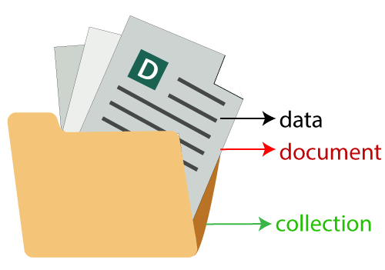

After Cloud Firestore's NoSQL data model, we can store data in documents that have field mappings for values. The documents are stored in a container called collections. These containers are used to organize our data and create queries. There are different data types, from simple string and numbers to complex nested objects, supported by documents. We can also create sub-collection within a document and create a hierarchical data structure that scales to the growth of our database. The Firestore data model supports whatever data structure works best for our app.

Additionally, the query in Cloud Firestore is expressive, efficient, and flexible. The shallow queries are created to retrieve data at the document level without the need to retrieve the entire collection or any nested subdivision. Add sorting, filtering, and limits for our queries or cursors to index the result. Add a real-time listener to our app for keeping the data running. Every time it is updated without recovering our entire database.

Adding real-time listeners to our app informs us with a data snapshot whenever our customer apps are changing data, only getting new changes.

For protecting our data access in Cloud Firestore, Firebase authentication, and Cloud Firestore security rules are used for Identity and Access Management (IAM).

# Firestore vs. Realtime Database

For the development of any application such as desktop, mobile, and web, a database is our prerequisite to store data. Storage is required where we can store and manipulate the data in such a way that every application can access the same data. Firebase provides Firestore and Firebase Realtime Database. These databases are cloud-based, client accessible database solutions which support real-time data syncing.

## **Cloud Firestore**

Firestore is the newest database used for mobile app development. Cloud Firestore has richer features, faster queries, and scale further than the real-time database. Cloud Firestore is a flexible as well as scalable NoSQL cloud database. It is used to store and sync data for client and server-side development. It is used for mobile, web, and server development from Google Cloud Platform and Firebase.

## **Realtime Database**

It is the original database of Firebase. It is a low latency solution and efficient for mobile applications which require synced states across the client's real-time. The Firebase Realtime Database is a cloud-hosted database in which data is stored as JSON. The data is synchronized in real-time to every connected client.

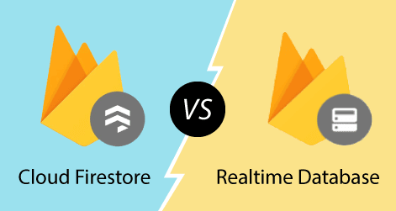

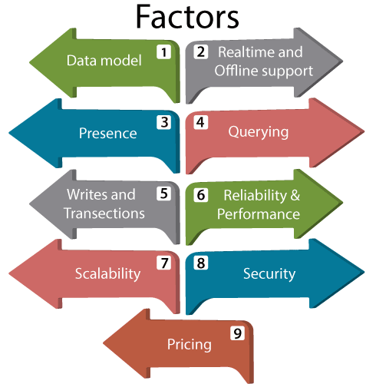

|  |  |
| --- | --- |
| **Realtime Database** | **Cloud Firestore** |
| In the Realtime database, data is stored as one large JSON tree. | In Cloud Firestore, data is stored as a collection of documents. |
| The data is simple, so it is very easy to store. | In documents, simple data is very easy to store. Documents are very similar to JSON. |
| The complex, hierarchical data is difficult to organize on a large scale. | By using sub-collections, the complex and hierarchical data is easy to organize on a large scale. It requires very less de-normalization and data flattening. |

|  |  |
| --- | --- |
| **Realtime Database** | **Cloud Firestore** |
| Offline support for Android and iOS clients. | Offline support for Android and iOS clients. |

|  |  |
| --- | --- |
| **Realtime Database** | **Cloud Firestore** |
| Realtime database supports presence. | The Firestore doesn't support presence natively. We can take advantage of the help of real-time databases by syncing Cloud Firestore and Firebase Realtime database using cloud functions. |

|  |  |
| --- | --- |
| **Realtime Database** | **Cloud Firestore** |
| It allows us to perform deep queries with limited sorting and filtering functionality. | It allows us to perform indexed queries with compound sorting and filtering. |
| The queries can sort or filter on a property, but not for both. | In Cloud Firestore, we can chain filter and combine filtering and sorting on a property in a single query. |
| It has deep queries by default, so it always returns the entire subtree. | It has shallow queries, so these queries return documents in a particular collection or collection group. These queries don't return sub collection data. |
| Realtime database queries can access data at any point, down to individual leaf-node values in the JSON tree. | Cloud Firestore queries always return whole documents. |
| These queries don't require an index. But, the performance of certain queries degrades as our dataset grows. | Cloud Firestore queries are indexed by default. The performance of the query is proportional to the size of our result set rather than a dataset. |

### **Scalability**

|  |  |
| --- | --- |
| **Realtime Database** | **Cloud Firestore** |
| Sharding is required for scaling. | Here, scaling is automatic. |
| It scales approximately 200000 concurrent connections, and 1000 writes per second in a single database. Beyond that, it is required to divide the data into multiple databases. | The scaling is done automatically. At present, it can scale up to 1 million concurrent connections, and 10000 writes per second. The limits can be increased in the future. |
| For an individual piece of data, there is no local limit on write rates. | It has limits for individual documents or indexes. |

### **Security**

|  |  |
| --- | --- |
| **Realtime Database** | **Cloud Firestore** |
| It uses cascading rules-language, which separates authorization and validation. | It uses no-cascading rules which combine authorization and validation. |
| By Realtime database rules, reads and writes from mobile SDKs secured. | With the help of Cloud Firestore security rules, reads and writes from server SDKs secured. |
| The read and write rules are a cascade. | The rules are not cascaded unless we use a wildcard. |
| The data is validated separately using the validation rule. | The rules can constrain queries. If the result of the query might contain data, the user doesn't have to access it, then the entire query fails. |

### **Pricing**

|  |  |
| --- | --- |
| **Realtime Database** | **Cloud Firestore** |
| Charges for bandwidth and storage only, but at a higher rate. | Mainly the operations performed in our database and are charged at a low rate, bandwidth, and storage. |

**Creating a firebase account:**

**One need to have a gmail account to start using firebase.**

**URL:** [**https://console.firebase.google.com/**](https://console.firebase.google.com/)

**Create a project inside it.**

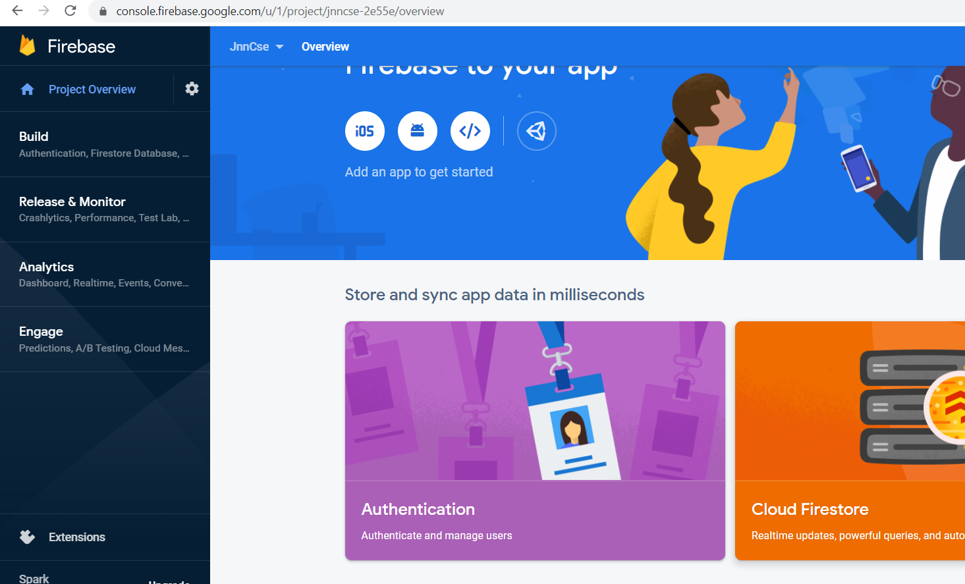

**Goto Cloud Firestore**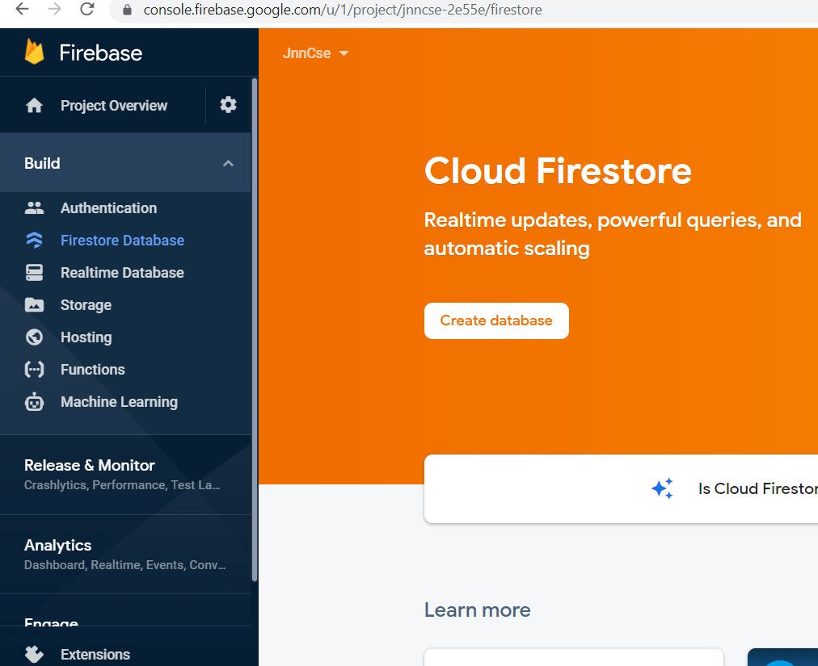

**Create database option**

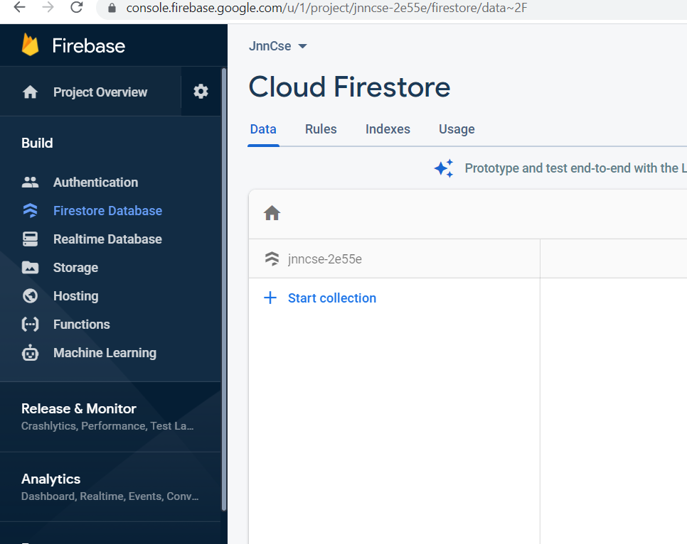

**Change rules to make it accessible**

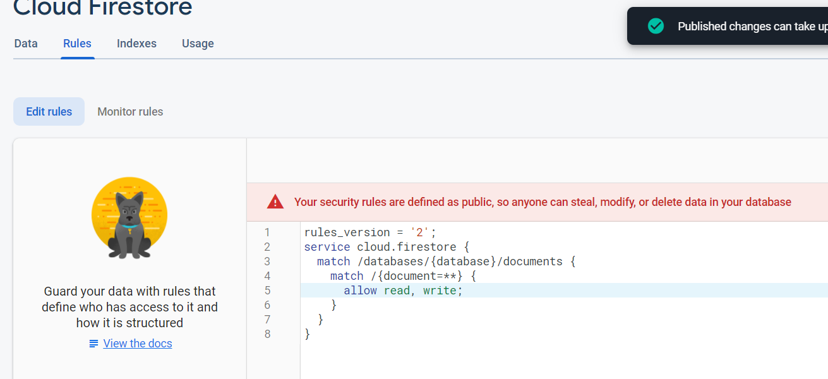

**Android:**

**Create a project with empty activity**

**Add firebase dependences:**

* 1. **build.gradle of Project**

Add this in dependencies block:

classpath **'com.google.gms:google-services:4.3.8'**

* 1. **build.gradle of App**

Add following:

Before android section:

apply **plugin**: **'com.google.gms.google-services'**

Inside default section

multiDexEnabled **true**

**Inside dependencies section:**

implementation **'androidx.multidex:multidex:2.0.1'**

implementation platform(**'com.google.firebase:firebase-bom:28.1.0'**)  
implementation **'com.google.firebase:firebase-analytics-ktx'**implementation **'com.firebaseui:firebase-ui-firestore:6.2.1'**implementation **'com.github.bumptech.glide:glide:4.11.0'**annotationProcessor **'com.github.bumptech.glide:compiler:4.11.0'**

**Click SyncNow for Gradle**

**Note: Syncing requires internet, so if internet is disconnected, results are indeterminate**

**activity_main.xml:**

*<?***xml version="1.0" encoding="utf-8"***?>*<**androidx.constraintlayout.widget.ConstraintLayout xmlns:android="http://schemas.android.com/apk/res/android"  
 xmlns:app="http://schemas.android.com/apk/res-auto"  
 xmlns:tools="http://schemas.android.com/tools"  
 android:layout_width="match_parent"  
 android:layout_height="match_parent"  
 tools:context=".MainActivity"**>  
  
 <**LinearLayout  
 android:layout_width="match_parent"  
 android:layout_height="match_parent"  
 android:orientation="vertical"**>  
  
 <**EditText  
 android:id="@+id/pid"  
 android:layout_width="100sp"  
 android:layout_height="wrap_content"  
 android:ems="10"  
 android:hint="Product ID"  
 android:inputType="textPersonName"** />  
  
 <**EditText  
 android:id="@+id/pname"  
 android:layout_width="200sp"  
 android:layout_height="wrap_content"  
 android:ems="10"  
 android:hint="Product Name"  
 android:inputType="textPersonName"** />  
  
 <**EditText  
 android:id="@+id/cost"  
 android:layout_width="80sp"  
 android:layout_height="wrap_content"  
 android:ems="10"  
 android:hint="Cost"  
 android:inputType="numberDecimal"** />  
  
 <**Spinner  
 android:id="@+id/ptyp"  
 android:layout_width="wrap_content"  
 android:layout_height="wrap_content"  
 android:entries="@array/product_cat"** />  
  
 <**Button  
 android:id="@+id/button"  
 android:layout_width="200sp"  
 android:layout_height="wrap_content"  
 android:onClick="add"  
 android:text="Add/Update"** />  
  
 <**androidx.recyclerview.widget.RecyclerView  
 android:layout_width="match_parent"  
 android:layout_height="match_parent"  
 android:id="@+id/rv"**/>  
  
 </**LinearLayout**>  
</**androidx.constraintlayout.widget.ConstraintLayout**>

MainActivity.kt:

**class** MainActivity : AppCompatActivity() {  
 **private var mAuth**: FirebaseAuth?=**null  
 private var mFirebaseDatabaseInstances**:FirebaseFirestore?=**null  
 lateinit var cv**:RecyclerView  
 **override fun** onCreate(savedInstanceState: Bundle?) {  
 **super**.onCreate(savedInstanceState)  
 setContentView(R.layout.*activity_main*)  
 *//Get Firebase Instances* **val** policy = StrictMode.ThreadPolicy.Builder().permitAll().build()  
 StrictMode.setThreadPolicy(policy)  
 **mAuth**=FirebaseAuth.getInstance()  
 **mFirebaseDatabaseInstances**= FirebaseFirestore.getInstance()  
 **cv**=findViewById<View>(R.id.*rv*) **as** RecyclerView  
 loadData()  
  
  
 }  
 **fun** add(v: View?)  
 {  
 **var** pidA=findViewById<View>(R.id.*pid*) **as** EditText  
 **var** pnameA=findViewById<View>(R.id.*pname*) **as** EditText  
 **var** pcostA=findViewById<View>(R.id.*cost*) **as** EditText  
 **var** ptypA=findViewById<View>(R.id.*ptyp*) **as** Spinner  
 **var** pid=pidA.*text*.toString()  
 **var** pname=pnameA.*text*.toString()  
 **var** pcost=pcostA.*text*.toString().*toDouble*()  
 **var** ptyp=ptypA.*selectedItem*.toString()  
 **val** docRef=**mFirebaseDatabaseInstances**?.collection(**"products"**)?.document(pid!!)  
 **var** url=**""**

docRef?.get()?.addOnSuccessListener **{** documentSnapshot **->  
 val** prod=documentSnapshot.toObject(Product::**class**.*java*) **as** Product  
**if**(prod!=**null**)  
 url=prod!!.**url**

*//Toast.makeText(this,url,Toast.LENGTH_LONG).show()* **var** p=Product(pid,pname,pcost,url,ptyp)  
 **mFirebaseDatabaseInstances**?.collection(**"products"**)?.document(pid!!)?.set(p)  
 Toast.makeText(**this**,**"Product added successfully"**,Toast.*LENGTH_LONG*).show()

**}**

}  
  
 **fun** loadData()  
 {  
 **val** query: Query = FirebaseFirestore.getInstance()  
 .collection(**"products"**)  
 **val** options: FirestoreRecyclerOptions<Product?> = FirestoreRecyclerOptions.Builder<Product>()  
 .setQuery(query, Product::**class**.*java*)  
 .build()  
 **val** adapter: FirestoreRecyclerAdapter<*, *> = **object** : FirestoreRecyclerAdapter<Product?, RecyclerView.ViewHolder?>(options) {  
  
 **override fun** onCreateViewHolder(group: ViewGroup, i: Int): ProductHolder {  
 *// Using a custom layout called R.layout.message for each item, we create a new instance of the viewholder* **val** view: View = LayoutInflater.from(group.*context*)  
 .inflate(R.layout.*list_data*, group, **false**)  
 **return** ProductHolder(view)  
 }  
  
  
  
 **override fun** onBindViewHolder(holder: RecyclerView.ViewHolder, position: Int, model: Product) {  
  
 (holder.**itemView**.findViewById<View>(R.id.*tpid*) **as** TextView).setText(**"Product ID: "**+model.**pid**)  
 (holder.**itemView**.findViewById<View>(R.id.*tpname*) **as** TextView).setText(**"Product Name:"**+ model.**pname**)  
 (holder.**itemView**.findViewById<View>(R.id.*tpcost*) **as** TextView).setText(**"Product Cost:"**+model.**cost**.toString())  
 (holder.**itemView**.findViewById<View>(R.id.*tptyp*) **as** TextView).setText(**"Product Category:"**+model.**typ**)  
 **if**(model.**url**!=**""**) {  
 */*Thread(  
 Runnable {  
  
 var url = URL(model.url)  
 runOnUiThread {  
 var bm = BitmapFactory.decodeStream(url.openConnection().getInputStream())  
 (holder.itemView.findViewById<View>(R.id.imageView) as ImageView).setImageBitmap(bm)  
 }  
 }  
  
 ).start();*/* **var** url = URL(model.**url**)  
 **var** imageView=(holder.**itemView**.findViewById<View>(R.id.*imageView*) **as** ImageView)  
 Glide.with(**this**@MainActivity).load(model.**url**).placeholder(R.drawable.*prod*).error(R.drawable.*prod*).override(600,600).into(imageView);  
 }  
 (holder.**itemView**.findViewById<View>(R.id.*delBtn*) **as** ImageButton).setOnClickListener **{  
 mFirebaseDatabaseInstances**!!.collection(**"products"**).document(model.**pid**!!).delete()  
 .addOnSuccessListener **{** Toast.makeText(*applicationContext*, **"Successfully deleted "**, Toast.*LENGTH_SHORT*).show() **}** .addOnFailureListener **{** Toast.makeText(*applicationContext*, **"Unable to delete"**, Toast.*LENGTH_SHORT*).show() **}  
 }** (holder.**itemView**.findViewById<View>(R.id.*uploadBtn*) **as** ImageButton).setOnClickListener **{  
 var** i= Intent(*applicationContext*,UploadActivity::**class**.*java*)  
 i.putExtra(**"pid"**,model.**pid**)  
 i.putExtra(**"pname"**,model.**pname**)  
 i.putExtra(**"cost"**,model.**cost**.toString())  
 i.putExtra(**"typ"**,model.**typ**)  
 startActivity(i)  
 **}** }  
  
  
 }  
*//Final step, where "mRecyclerView" is defined in your xml layout as  
//the recyclerview  
//Final step, where "mRecyclerView" is defined in your xml layout as  
//the recyclerview* **cv**.*layoutManager* = LinearLayoutManager(**this**)  
 **cv**.*adapter*=adapter  
 adapter.startListening()  
 }  
  
  
}  
**class** Product  
{  
 **var pid**=**""  
 var pname**=**""  
 var cost**=0.0  
 **var typ**=**""  
 var url**=**""  
  
 constructor**(pid:String,pname:String,cost:Double,url:String,typ:String)  
 {  
 **this**.**pid**=pid  
 **this**.**pname**=pname  
 **this**.**cost**=cost  
 **this**.**url**=url  
 **this**.**typ**=typ  
  
 }  
 **constructor**()  
}  
**class** ProductHolder(itemView: View):RecyclerView.ViewHolder(itemView) {  
 **val tpid**: TextView  
 **val tpname**: TextView  
 **val tpcost**: TextView  
 **val tptyp**:TextView  
 **init** {  
 **tpid**=itemView.findViewById(R.id.*tpid*)  
  
 **tpname**=itemView.findViewById(R.id.*tpname*)  
 **tpcost**=itemView.findViewById(R.id.*tpcost*)  
 **tptyp**=itemView.findViewById(R.id.*tptyp*)  
 }  
  
  
}

For all Firebase related APIs in code, click add dependencies and dependencies are automatically added

Create a new layout file (inside res/layout folder)

layout_data.xml:

*<?***xml version="1.0" encoding="utf-8"***?>*<**androidx.cardview.widget.CardView xmlns:android="http://schemas.android.com/apk/res/android"  
 xmlns:app="http://schemas.android.com/apk/res-auto"  
 xmlns:tools="http://schemas.android.com/tools"  
 android:layout_width="wrap_content"  
 android:layout_height="wrap_content"  
 android:layout_margin="5dp"  
 android:layout_marginBottom="30dp"  
 android:orientation="vertical"**>  
  
 <**LinearLayout  
 android:layout_width="wrap_content"  
  
 android:layout_height="wrap_content"  
 android:layout_marginBottom="25dp"  
 android:orientation="horizontal"**>  
  
 <**ImageView  
 android:id="@+id/imageView"  
 android:layout_width="100dp"  
 android:layout_height="100dp"  
 android:layout_marginEnd="20sp"  
 android:layout_marginRight="20sp"  
 android:src="@drawable/prod"** />  
  
 <**LinearLayout  
 android:layout_width="130dp"  
 android:layout_height="wrap_content"  
 android:layout_marginEnd="20sp"  
 android:layout_marginRight="20sp"  
 android:orientation="vertical"**>  
  
 <**TextView  
 android:id="@+id/tpid"  
 android:layout_width="wrap_content"  
  
 android:layout_height="wrap_content"  
 android:layout_gravity="start"  
 android:gravity="left"  
 android:text="ProductID"  
 android:textColor="#E34B4B"  
 android:textSize="14dp"** />  
  
 <**TextView  
 android:id="@+id/tpname"  
 android:layout_width="wrap_content"  
  
 android:layout_height="wrap_content"  
 android:layout_gravity="start"  
 android:layout_marginTop="5sp"  
 android:text="Product Name"  
 android:textColor="#E36969"  
 android:textSize="14dp"** />  
  
 <**TextView  
 android:id="@+id/tpcost"  
 android:layout_width="match_parent"  
 android:layout_height="wrap_content"  
 android:layout_gravity="start"  
 android:layout_marginTop="5sp"  
 android:text="Product Cost"  
 android:textColor="#C65151"  
 android:textSize="14dp"** />  
  
 <**TextView  
 android:id="@+id/tptyp"  
 android:layout_width="match_parent"  
 android:layout_height="wrap_content"  
 android:text="Product Category"  
 android:textColor="#A32626"** />  
  
 </**LinearLayout**>  
  
 <**LinearLayout  
 android:layout_width="83dp"  
 android:layout_height="46dp"  
 android:orientation="horizontal"**>  
  
 <**ImageButton  
 android:id="@+id/delBtn"  
 android:layout_width="20dp"  
 android:layout_height="60dp"  
 android:layout_marginTop="10dp"  
 android:background="#FFFFFF"  
 android:src="@android:drawable/ic_menu_delete"  
 android:tint="#F40F0F"** />  
  
<**ImageButton  
 android:id="@+id/uploadBtn"  
 android:layout_width="20dp"  
 android:layout_height="60dp"  
 android:layout_marginStart="10sp"  
 android:layout_marginLeft="10sp"  
 android:layout_marginTop="10dp"  
 android:background="#FFFFFF"  
 android:src="@android:drawable/ic_menu_upload"  
 android:tint="#045C2F"** />

</**LinearLayout**>  
  
 </**LinearLayout**>  
  
</**androidx.cardview.widget.CardView**>

**Also put a prod image**

**Further create array of product categories inside strings.xml of res/values folder:**

<**resources**>  
 <**string name="app_name"**>PFB</**string**>  
 <**string-array name="product_cat"**>  
 <**item**>Household</**item**>  
 <**item**>Electronic</**item**>  
 <**item**>Eatable</**item**>  
 <**item**>Others</**item**>  
  
 </**string-array**>  
</**resources**>

**Create next Activity-Upload**

**In Firebase link this app**

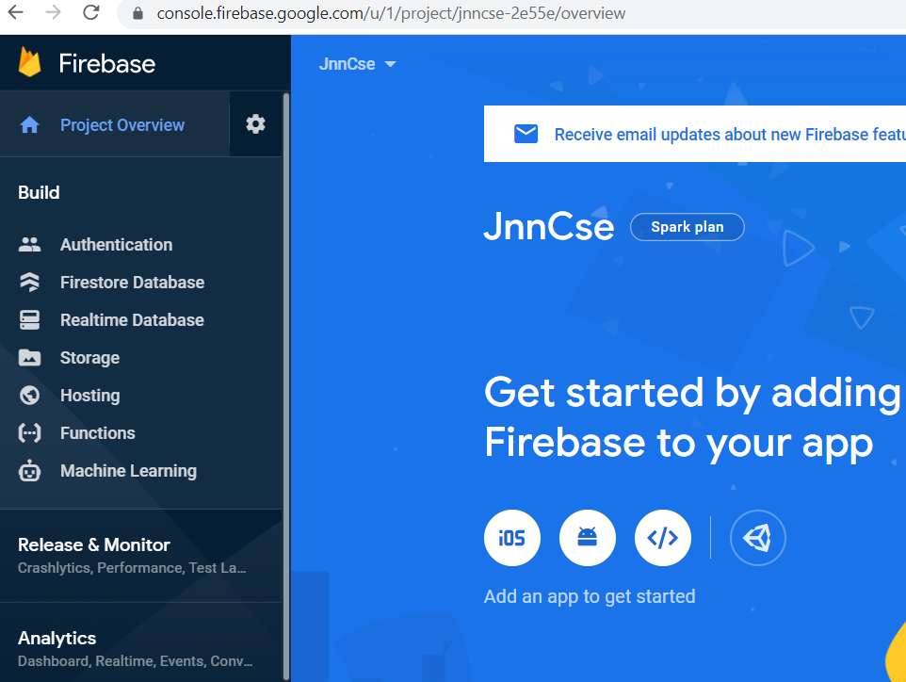

**Use Add an app**

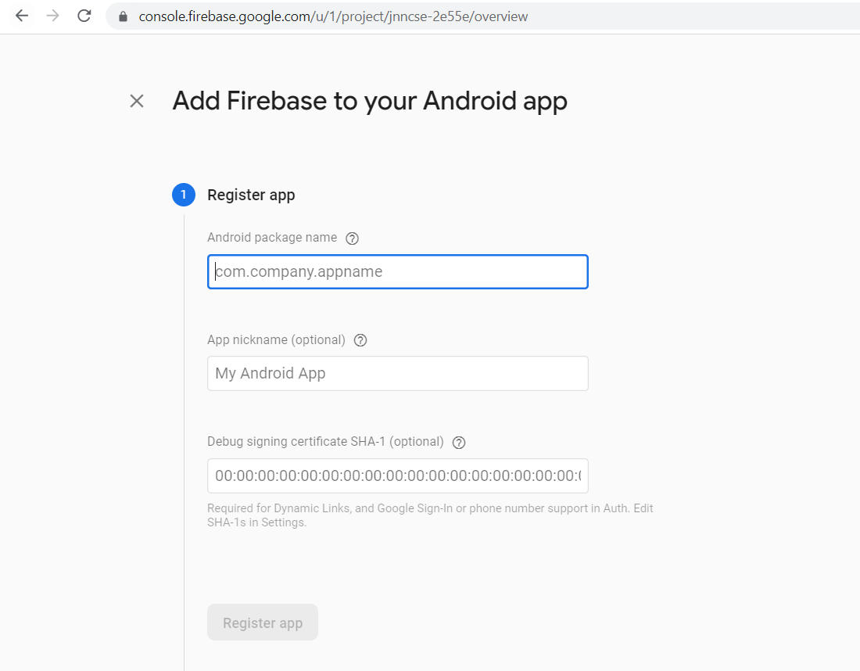

**Package name should be same as android app package name**

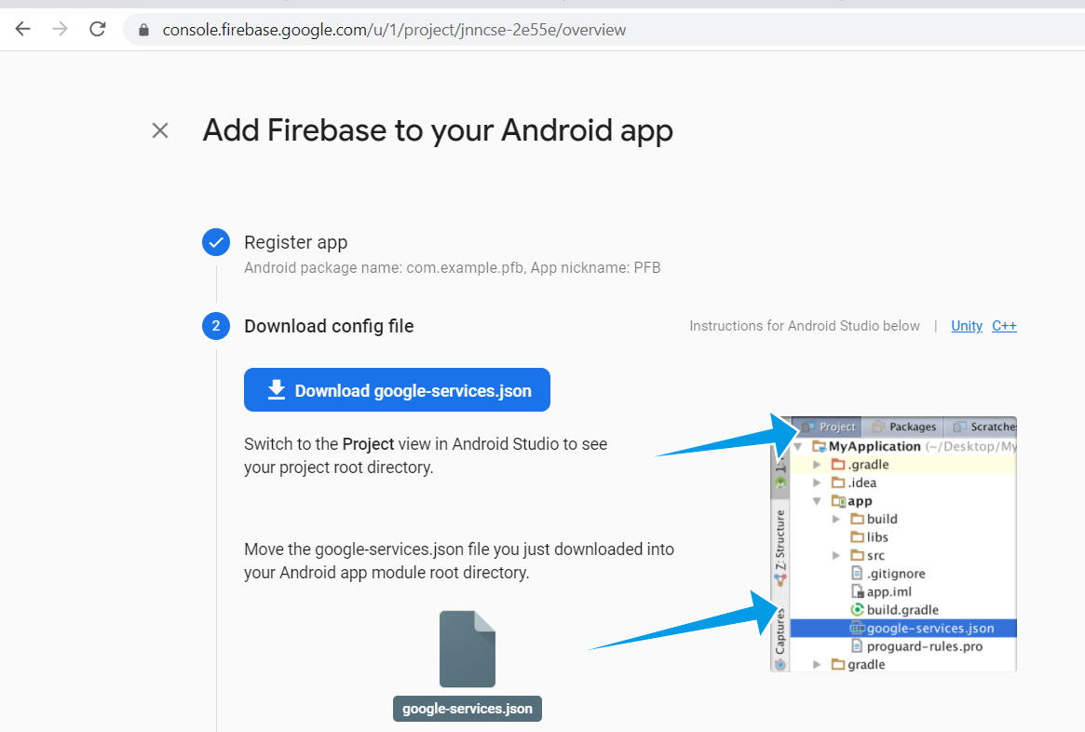

**Download google-services.json and put inside app folder**

**Goto Storage option in Firebase project and create a folder uploads:**

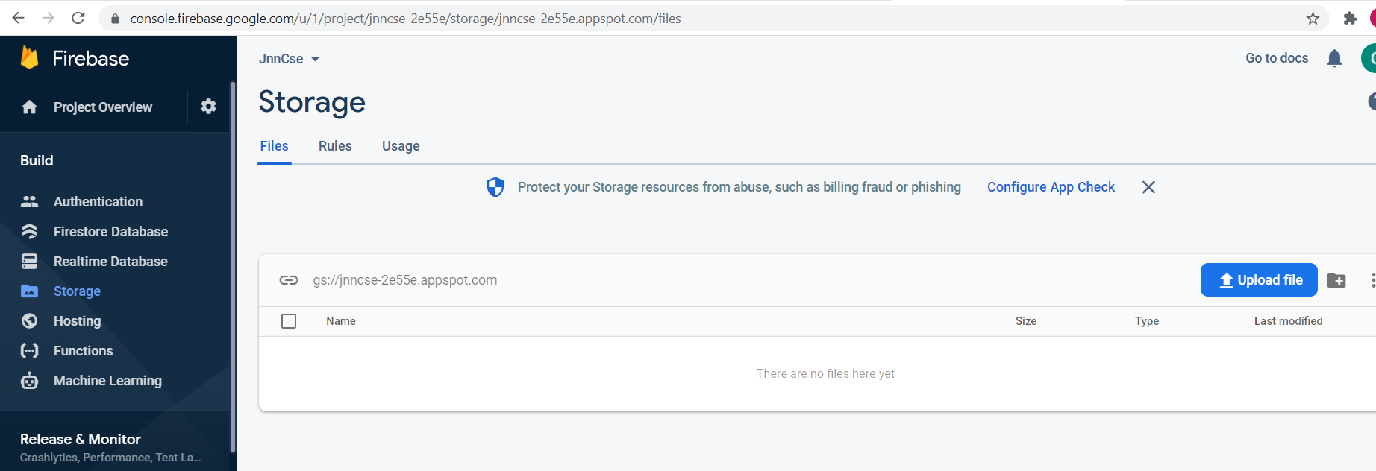

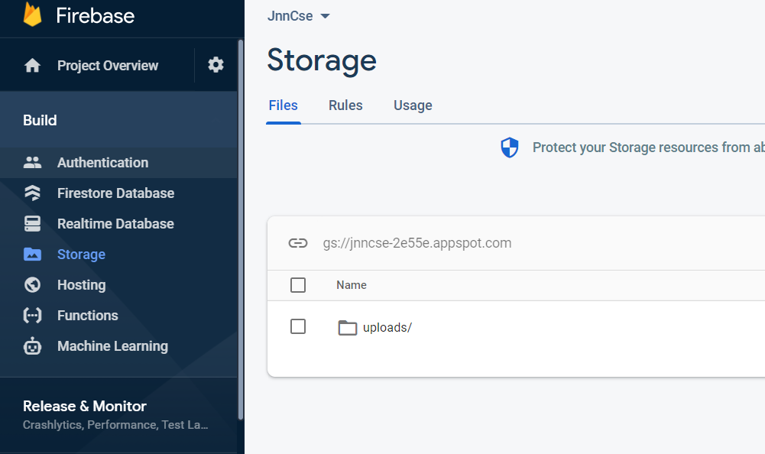

**Edit rules section to make it accessible:**

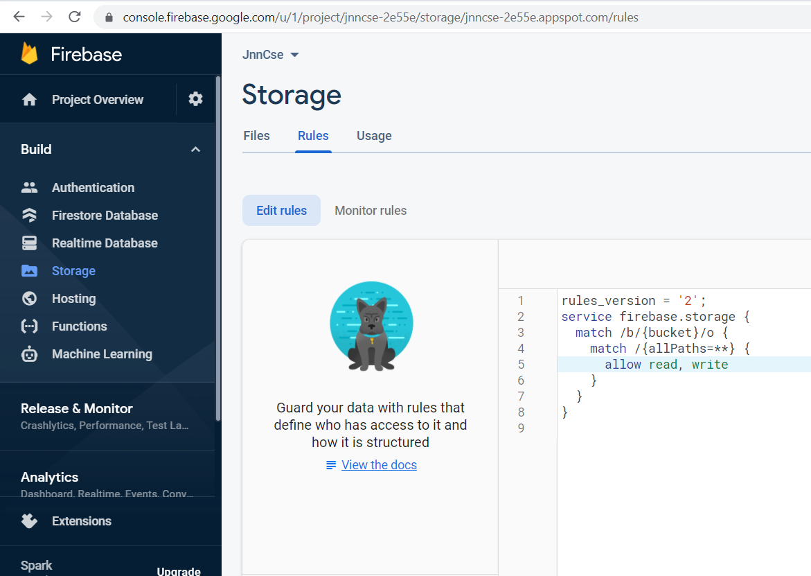

**Upload Activity details:**

**activity_upload.xml**

*<?***xml version="1.0" encoding="utf-8"***?>*<**androidx.constraintlayout.widget.ConstraintLayout xmlns:android="http://schemas.android.com/apk/res/android"  
 xmlns:app="http://schemas.android.com/apk/res-auto"  
 xmlns:tools="http://schemas.android.com/tools"  
 android:layout_width="match_parent"  
 android:layout_height="match_parent"  
 tools:context=".UploadActivity"**>  
  
 <**LinearLayout  
 android:layout_width="match_parent"  
 android:layout_height="match_parent"  
 app:layout_behavior="@string/appbar_scrolling_view_behavior"  
  
 tools:context=".GalleryActivity"  
 android:padding="30dp"  
 android:orientation="vertical"** >  
  
 <**ImageView  
 android:id="@+id/uI"  
 android:layout_width="wrap_content"  
 android:layout_height="391dp"  
 android:src="@drawable/prod"** />  
  
 <**Button  
 android:id="@+id/btn_choose_image"  
 android:layout_width="match_parent"  
 android:layout_height="wrap_content"  
 android:onClick="launchGallery"  
 android:text="Choose image"** />  
  
 <**Button  
 android:id="@+id/btn_upload_image"  
 android:layout_width="match_parent"  
 android:layout_height="wrap_content"  
 android:onClick="uploadImage"  
 android:text="Upload image"** />  
  
 </**LinearLayout**>  
</**androidx.constraintlayout.widget.ConstraintLayout**>

**UploadActivity.kt:**

**class** UploadActivity : AppCompatActivity() {  
 **private val PICK_IMAGE_REQUEST** = 71  
 **private var filePath**: Uri? = **null  
 private var firebaseStore**: FirebaseStorage? = **null  
 private var storageReference**: StorageReference? = **null  
 private var mFirebaseDatabaseInstances**:FirebaseFirestore?=**null  
 var pid**=**""  
 var pname**=**""  
 var cost**=0.0  
 **var url**=**""  
 var typ**=**""  
 override fun** onCreate(savedInstanceState: Bundle?) {  
 **super**.onCreate(savedInstanceState)  
 setContentView(R.layout.*activity_upload*)  
 **firebaseStore** = FirebaseStorage.getInstance()  
 **storageReference** = FirebaseStorage.getInstance().*reference* **var** i=*intent* **pid**=i.getStringExtra(**"pid"**).*toString*()  
 **pname**=i.getStringExtra(**"pname"**).*toString*()  
 **cost**=i.getStringExtra(**"cost"**)!!.*toDouble*()  
 **typ**=i.getStringExtra(**"typ"**).*toString*()  
  
  
 }  
 **fun** launchGallery(v:View?) {  
 **val** intent = Intent()  
 intent.*type* = **"image/*"** intent.*action* = Intent.*ACTION_GET_CONTENT* startActivityForResult(Intent.createChooser(intent, **"Select Picture"**), **PICK_IMAGE_REQUEST**)  
 }  
  
 **override fun** onActivityResult(requestCode: Int, resultCode: Int, data: Intent?) {  
 **super**.onActivityResult(requestCode, resultCode, data)  
 **if** (requestCode == **PICK_IMAGE_REQUEST** && resultCode == Activity.*RESULT_OK*) {  
 **if**(data == **null** || data.*data* == **null**){  
 **return** }  
  
 **filePath** = data.*data* **try** {  
 **val** bitmap = MediaStore.Images.Media.getBitmap(*contentResolver*, **filePath**)  
 **var** ui=findViewById<View>(R.id.*uI*) **as** ImageView  
 ui.setImageBitmap(bitmap)  
 } **catch** (e: IOException) {  
 e.printStackTrace()  
 }  
 }  
 }  
  
 **fun** addUploadRecordToDb(uri: String){  
 *//val db = FirebaseFirestore.getInstance()  
 // Toast.makeText(this,"inside..",Toast.LENGTH_LONG).show()* **mFirebaseDatabaseInstances**= FirebaseFirestore.getInstance()  
 **val** data = HashMap<String, Any>()  
  
  
  
  
 **url** = uri  
 *//Toast.makeText(this,"{$pid,$pname,$cost,$url}",Toast.LENGTH_LONG).show()* **var** p=Product(**pid**,**pname**,**cost**,**url**,**typ**)  
 **mFirebaseDatabaseInstances**?.collection(**"products"**)?.document(**pid**!!)?.set(p)  
 finish()  
 }  
  
 **fun** uploadImage(v:View?){  
 **if**(**filePath** != **null**){  
 **val** ref = **storageReference**?.child(**"uploads/"** + UUID.randomUUID().toString())  
 **val** uploadTask = ref?.putFile(**filePath**!!)  
  
 **val** urlTask = uploadTask?.continueWithTask(*Continuation*<UploadTask.TaskSnapshot, Task<Uri>> **{** task **->  
 if** (!task.*isSuccessful*) {  
 task.*exception*?.*let* **{  
 throw it  
 }** }  
 ref.*downloadUrl* **}**)?.addOnCompleteListener **{** task**->  
 if** (task.*isSuccessful*) {  
 **val** downloadUri = task.*result  
 // Toast.makeText(this,downloadUri.toString(),Toast.LENGTH_LONG).show()* addUploadRecordToDb(downloadUri.*toString*())  
 } **else** {  
 *// Handle failures* }  
 **}**?.addOnFailureListener**{  
  
 }** }**else**{  
 Toast.makeText(**this**, **"Please Upload an Image"**, Toast.*LENGTH_SHORT*).show()  
 }  
 }  
}

**Create Login Activity**

**activity_login.xml:**

*<?***xml version="1.0" encoding="utf-8"***?>*<**androidx.constraintlayout.widget.ConstraintLayout xmlns:android="http://schemas.android.com/apk/res/android"  
 xmlns:app="http://schemas.android.com/apk/res-auto"  
 xmlns:tools="http://schemas.android.com/tools"  
 android:layout_width="match_parent"  
 android:layout_height="match_parent"  
 tools:context=".LoginActivity"**>  
 <**LinearLayout  
 android:layout_width="match_parent"  
 android:layout_height="match_parent"  
 android:orientation="vertical"**>  
  
 <**TextView  
 android:id="@+id/textView"  
 android:layout_width="match_parent"  
 android:layout_height="wrap_content"  
 android:layout_marginTop="40sp"  
 android:gravity="center"  
 android:text="ADMIN LOGIN"  
 android:textSize="24sp"  
 android:textStyle="bold"** />  
  
 <**RelativeLayout  
 android:layout_width="wrap_content"  
 android:layout_height="wrap_content"  
 android:orientation="horizontal"**>  
  
 <**TextView  
 android:id="@+id/textView2"  
 android:layout_width="wrap_content"  
 android:layout_height="wrap_content"  
 android:layout_marginStart="30sp"  
 android:layout_marginLeft="30sp"  
 android:layout_marginTop="10sp"  
 android:layout_weight="1"  
 android:text="UserName:"** />  
  
 <**EditText  
 android:id="@+id/userName"  
 android:layout_width="wrap_content"  
 android:layout_height="wrap_content"  
 android:layout_toRightOf="@id/textView2"  
 android:layout_weight="1"  
 android:ems="10"  
 android:hint="Username"  
 android:inputType="textPersonName"** />  
  
 <**TextView  
 android:id="@+id/textView3"  
 android:layout_width="wrap_content"  
 android:layout_height="wrap_content"  
 android:layout_below="@id/textView2"  
 android:layout_marginStart="30sp"  
 android:layout_marginLeft="30sp"  
 android:layout_marginTop="30sp"  
 android:layout_weight="1"  
 android:text="Password"** />  
  
 <**EditText  
 android:id="@+id/passWord"  
 android:layout_width="wrap_content"  
 android:layout_height="wrap_content"  
 android:layout_below="@id/userName"  
 android:layout_toRightOf="@id/textView3"  
 android:ems="10"  
 android:inputType="textPassword"** />  
  
 </**RelativeLayout**>  
  
 <**Button  
 android:id="@+id/button"  
 android:layout_width="wrap_content"  
 android:layout_height="wrap_content"  
 android:layout_gravity="center"  
 android:layout_marginTop="40sp"  
 android:onClick="login"  
 android:text="Login"** />  
  
 <**Button  
 android:id="@+id/button2"  
 android:layout_width="wrap_content"  
 android:layout_height="wrap_content"  
 android:layout_gravity="center"  
 android:gravity="center"  
 android:onClick="guest"  
 android:text="Guest "** />  
 </**LinearLayout**>  
  
  
</**androidx.constraintlayout.widget.ConstraintLayout**>

**LoginActivity.kt:**

**class** LoginActivity : AppCompatActivity() {  
 **override fun** onCreate(savedInstanceState: Bundle?) {  
 **super**.onCreate(savedInstanceState)  
 setContentView(R.layout.*activity_login*)  
 }  
 **fun** login(v: View?)  
 {  
 **var** u=findViewById<View>(R.id.*userName*) **as** EditText  
 **var** p=findViewById<View>(R.id.*passWord*) **as** EditText  
 **if**(u.*text*.toString()==**"admin"** && p.*text*.toString()==**"jnnce"**)  
 {  
 **var** i= Intent(*applicationContext*,MainActivity::**class**.*java*)  
 startActivity(i)  
 }  
 **else** {  
 Toast.makeText(**this**,**"Invalid Admin Credentials"**,Toast.*LENGTH_LONG*).show()  
 }  
 }  
 **fun** guest(v:View?)  
 {  
 **var** i= Intent(*applicationContext*,GuestActivity::**class**.*java*)  
 startActivity(i)  
 }  
}

**GuestActivity:**

**activity_guest.xml:**

*<?***xml version="1.0" encoding="utf-8"***?>*<**androidx.constraintlayout.widget.ConstraintLayout xmlns:android="http://schemas.android.com/apk/res/android"  
 xmlns:app="http://schemas.android.com/apk/res-auto"  
 xmlns:tools="http://schemas.android.com/tools"  
 android:layout_width="match_parent"  
 android:layout_height="match_parent"  
 tools:context=".GuestActivity"**>  
 <**LinearLayout  
 android:layout_width="match_parent"  
 android:layout_height="match_parent"  
 android:orientation="vertical"**>  
  
  
  
 <**androidx.recyclerview.widget.RecyclerView  
 android:layout_width="match_parent"  
 android:layout_height="match_parent"  
 android:id="@+id/rv"**/>  
  
 </**LinearLayout**>  
  
</**androidx.constraintlayout.widget.ConstraintLayout**>

**GuestActivity.kt:**

**class** GuestActivity : AppCompatActivity() {  
 **private var mAuth**: FirebaseAuth?=**null  
 private var mFirebaseDatabaseInstances**: FirebaseFirestore?=**null  
 lateinit var cv**: RecyclerView  
 **override fun** onCreate(savedInstanceState: Bundle?) {  
 **super**.onCreate(savedInstanceState)  
 setContentView(R.layout.*activity_guest*)  
 **val** policy = StrictMode.ThreadPolicy.Builder().permitAll().build()  
 StrictMode.setThreadPolicy(policy)  
 **mAuth**=FirebaseAuth.getInstance()  
 **mFirebaseDatabaseInstances**= FirebaseFirestore.getInstance()  
 **cv**=findViewById<View>(R.id.*rv*) **as** RecyclerView  
 loadData()  
  
 }  
 **fun** loadData()  
 {  
 **val** query: Query = FirebaseFirestore.getInstance()  
 .collection(**"products"**)  
 **val** options: FirestoreRecyclerOptions<Product?> = FirestoreRecyclerOptions.Builder<Product>()  
 .setQuery(query, Product::**class**.*java*)  
 .build()  
 **val** adapter: FirestoreRecyclerAdapter<*, *> = **object** : FirestoreRecyclerAdapter<Product?, RecyclerView.ViewHolder?>(options) {  
  
 **override fun** onCreateViewHolder(group: ViewGroup, i: Int): ProductHolder {  
 *// Using a custom layout called R.layout.message for each item, we create a new instance of the viewholder* **val** view: View = LayoutInflater.from(group.*context*)  
 .inflate(R.layout.*list_guest*, group, **false**)  
 **return** ProductHolder(view)  
 }  
  
  
  
 **override fun** onBindViewHolder(holder: RecyclerView.ViewHolder, position: Int, model: Product) {  
  
 (holder.**itemView**.findViewById<View>(R.id.*tpid*) **as** TextView).setText(**"Product ID: "**+model.**pid**)  
 (holder.**itemView**.findViewById<View>(R.id.*tpname*) **as** TextView).setText(**"Product Name:"**+ model.**pname**)  
 (holder.**itemView**.findViewById<View>(R.id.*tpcost*) **as** TextView).setText(**"Product Cost:"**+model.**cost**.toString())  
 (holder.**itemView**.findViewById<View>(R.id.*tptyp*) **as** TextView).setText(**"Product Category:"**+model.**typ**)  
 **if**(model.**url**!=**""**) {  
 */*Thread(  
 Runnable {  
  
 var url = URL(model.url)  
 runOnUiThread {  
 var bm = BitmapFactory.decodeStream(url.openConnection().getInputStream())  
 (holder.itemView.findViewById<View>(R.id.imageView) as ImageView).setImageBitmap(bm)  
 }  
 }  
  
 ).start();*/* **var** url = URL(model.**url**)  
 **var** imageView=(holder.**itemView**.findViewById<View>(R.id.*imageView*) **as** ImageView)  
 Glide.with(**this**@GuestActivity).load(model.**url**).placeholder(R.drawable.*prod*).error(R.drawable.*prod*).override(600,600).into(imageView);  
 }  
  
  
 }  
  
  
 }  
*//Final step, where "mRecyclerView" is defined in your xml layout as  
//the recyclerview  
//Final step, where "mRecyclerView" is defined in your xml layout as  
//the recyclerview* **cv**.*layoutManager* = LinearLayoutManager(**this**)  
 **cv**.*adapter*=adapter  
 adapter.startListening()  
 }  
  
}

**list_guest.xml inside res/layout folder:**

*<?***xml version="1.0" encoding="utf-8"***?>*<**androidx.cardview.widget.CardView xmlns:android="http://schemas.android.com/apk/res/android"  
 xmlns:app="http://schemas.android.com/apk/res-auto"  
 xmlns:tools="http://schemas.android.com/tools"  
 android:layout_width="wrap_content"  
 android:layout_height="wrap_content"  
 android:layout_margin="5dp"  
 android:layout_marginBottom="30dp"  
 android:orientation="vertical"**>  
  
 <**LinearLayout  
 android:layout_width="wrap_content"  
  
 android:layout_height="wrap_content"  
 android:layout_marginBottom="25dp"  
 android:orientation="horizontal"**>  
  
 <**ImageView  
 android:id="@+id/imageView"  
 android:layout_width="100dp"  
 android:layout_height="100dp"  
 android:layout_marginEnd="20sp"  
 android:layout_marginRight="20sp"  
 android:src="@drawable/prod"** />  
  
 <**LinearLayout  
 android:layout_width="250dp"  
 android:layout_height="wrap_content"  
 android:layout_marginEnd="20sp"  
 android:layout_marginRight="20sp"  
 android:orientation="vertical"**>  
  
 <**TextView  
 android:id="@+id/tpid"  
 android:layout_width="wrap_content"  
  
 android:layout_height="wrap_content"  
 android:layout_gravity="start"  
 android:gravity="left"  
 android:text="ProductID"  
 android:textColor="#E34B4B"  
 android:textSize="14dp"** />  
  
 <**TextView  
 android:id="@+id/tpname"  
 android:layout_width="wrap_content"  
  
 android:layout_height="wrap_content"  
 android:layout_gravity="start"  
 android:layout_marginTop="5sp"  
 android:text="Product Name"  
 android:textColor="#E36969"  
 android:textSize="14dp"** />  
  
 <**TextView  
 android:id="@+id/tpcost"  
 android:layout_width="match_parent"  
 android:layout_height="wrap_content"  
 android:layout_gravity="start"  
 android:layout_marginTop="5sp"  
 android:text="Product Cost"  
 android:textColor="#C65151"  
 android:textSize="14dp"** />  
  
 <**TextView  
 android:id="@+id/tptyp"  
 android:layout_width="match_parent"  
 android:layout_height="wrap_content"  
 android:text="Product Category"  
 android:textColor="#A32626"** />  
  
 </**LinearLayout**>  
  
  
  
 </**LinearLayout**>  
  
</**androidx.cardview.widget.CardView**>

**Change in manifest to start LoginActvity on app start:**

**Updated manifest.xml:**

*<?***xml version="1.0" encoding="utf-8"***?>*<**manifest xmlns:android="http://schemas.android.com/apk/res/android"  
 package="com.example.pfb"**>  
  
 <**application  
 android:allowBackup="true"  
 android:icon="@mipmap/ic_launcher"  
 android:label="@string/app_name"  
 android:roundIcon="@mipmap/ic_launcher_round"  
 android:supportsRtl="true"  
 android:theme="@style/Theme.PFB"**>  
 <**activity android:name=".GuestActivity"**></**activity**>  
 <**activity android:name=".LoginActivity"** >  
 <**intent-filter**>  
 <**action android:name="android.intent.action.MAIN"** />  
  
 <**category android:name="android.intent.category.LAUNCHER"** />  
 </**intent-filter**>  
 </**activity**>  
 <**activity android:name=".UploadActivity"** />  
 <**activity android:name=".MainActivity"**>  
   
 </**activity**>  
 </**application**>  
  
</**manifest**>

**Create a splash activity before login**

**activity_splash.xml:**

*<?***xml version="1.0" encoding="utf-8"***?>*<**androidx.constraintlayout.widget.ConstraintLayout xmlns:android="http://schemas.android.com/apk/res/android"  
 xmlns:app="http://schemas.android.com/apk/res-auto"  
 xmlns:tools="http://schemas.android.com/tools"  
 android:layout_width="match_parent"  
 android:layout_height="match_parent"  
 tools:context=".SplashActivity"**>  
  
 <**LinearLayout  
 android:layout_width="match_parent"  
 android:layout_height="wrap_content"  
 android:orientation="vertical"**>  
  
 <**ImageView  
 android:id="@+id/imageView2"  
 android:layout_width="wrap_content"  
 android:layout_height="400dp"  
 app:srcCompat="@drawable/slimwall"** />  
  
 <**Button  
 android:id="@+id/button3"  
 android:layout_width="wrap_content"  
 android:layout_height="wrap_content"  
 android:layout_gravity="center"  
 android:onClick="proceed"  
 android:text="CLICK TO PROCEED"** />  
 </**LinearLayout**>  
</**androidx.constraintlayout.widget.ConstraintLayout**>

**SplashActivity.xml:**

**class** SplashActivity : AppCompatActivity() {  
 **override fun** onCreate(savedInstanceState: Bundle?) {  
 **super**.onCreate(savedInstanceState)  
 setContentView(R.layout.*activity_splash*)  
 }  
 **fun** proceed(v: View?)  
 {  
 **var** i= Intent(*applicationContext*,LoginActivity::**class**.*java*)  
 startActivity(i)  
  
 }  
}

**Change manifest.xml to start Splash Activity at beginning:**

**Updated AndroidManifest.xml:**

*<?***xml version="1.0" encoding="utf-8"***?>*<**manifest xmlns:android="http://schemas.android.com/apk/res/android"  
 package="com.example.pfb"**>  
  
 <**application  
 android:allowBackup="true"  
 android:icon="@mipmap/ic_launcher"  
 android:label="@string/app_name"  
 android:roundIcon="@mipmap/ic_launcher_round"  
 android:supportsRtl="true"  
 android:theme="@style/Theme.PFB"**>  
 <**activity android:name=".SplashActivity"**>  
 <**intent-filter**>  
 <**action android:name="android.intent.action.MAIN"** />  
  
 <**category android:name="android.intent.category.LAUNCHER"** />  
 </**intent-filter**>  
 </**activity**>  
 <**activity android:name=".GuestActivity"** />  
 <**activity android:name=".LoginActivity"**>  
  
 </**activity**>  
 <**activity android:name=".UploadActivity"** />  
 <**activity android:name=".MainActivity"**></**activity**>  
 </**application**>  
  
</**manifest**>